Steps to reschedule Pick Release programs:
- Open request in failed responsibility.
- Click on view Details.

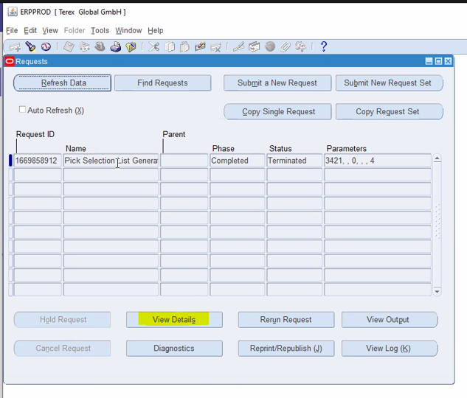
- Click on parameters

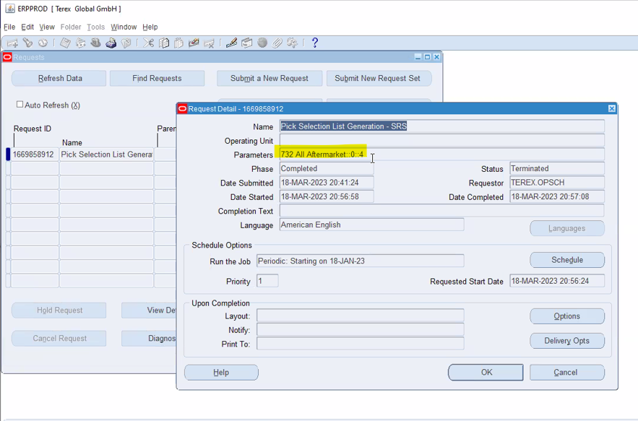

- Copy release rule name
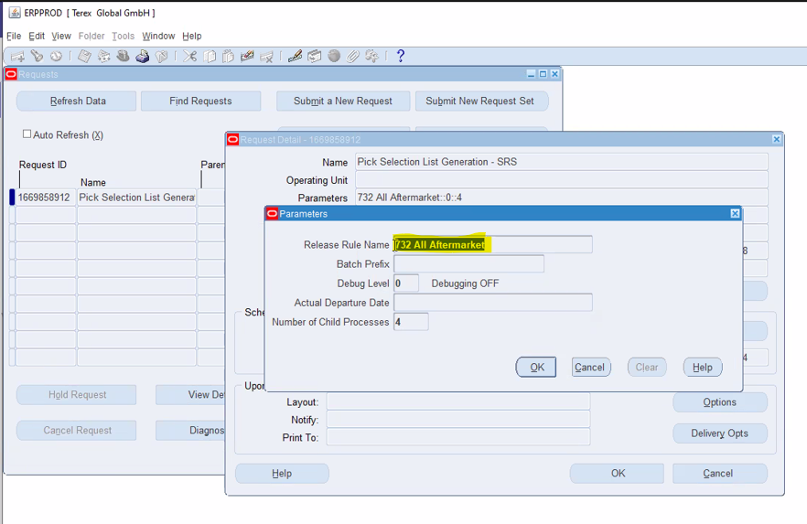
- Close the view detail from and request from.
- In the Navigation from, double click on Release Sales Orders SRS.

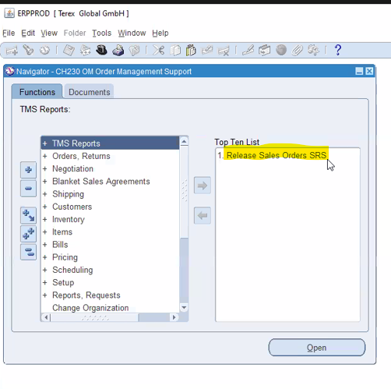
- Once the page opens pass the copied ruled name in parameter and remove actual departure date and clock on OK.
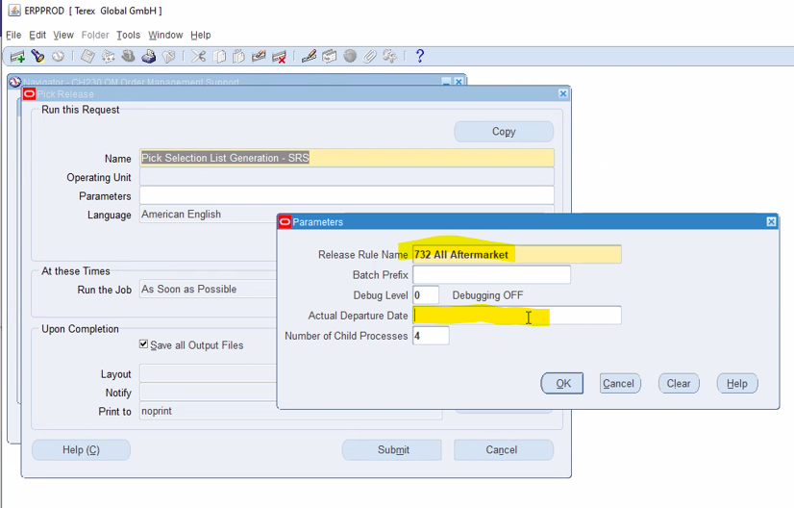

- Click on schedule.
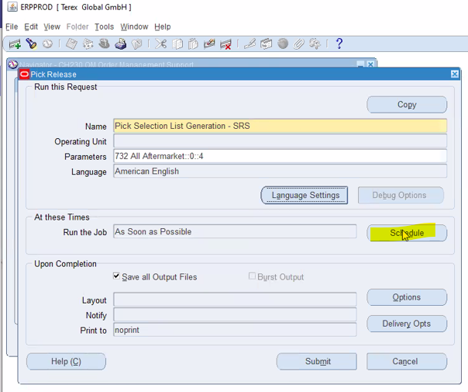

- Follow this step as per request parameters:
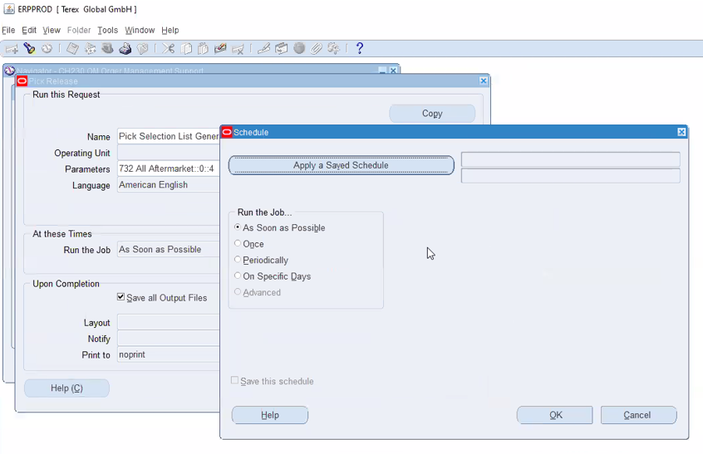

- Based on highlighted parameter in request fill the schedule carefully and click on OK.

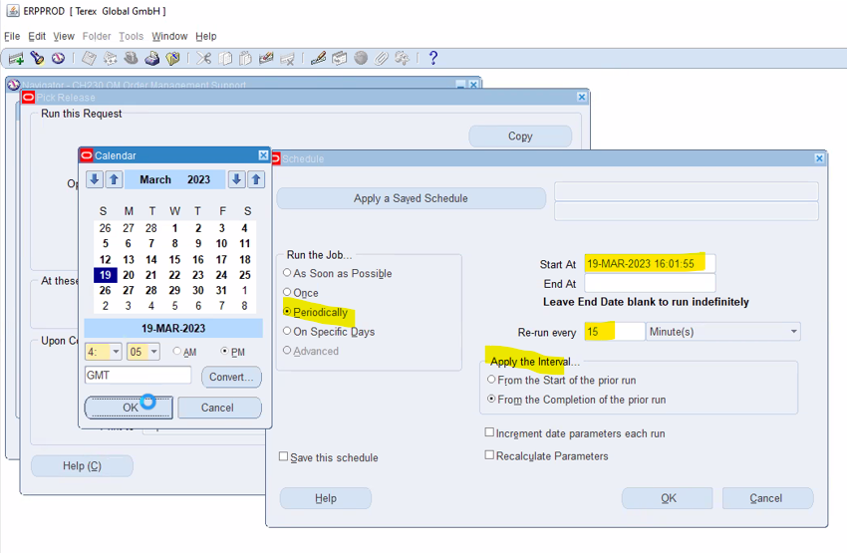
- Click on submit

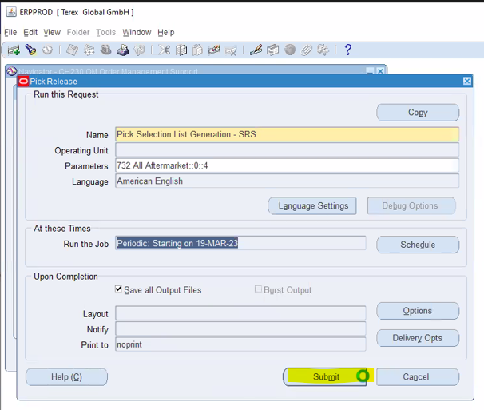

- Click on NO.

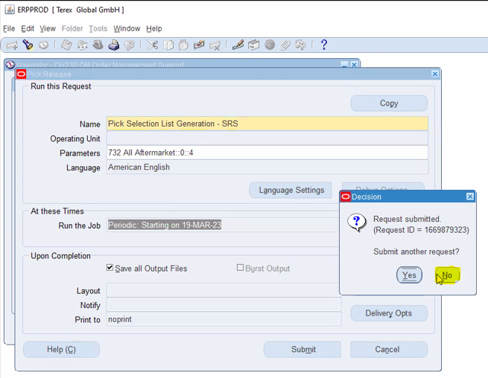

- Done.

